Connect the Mega plus board we provide to your computer, and open Arduino IDE

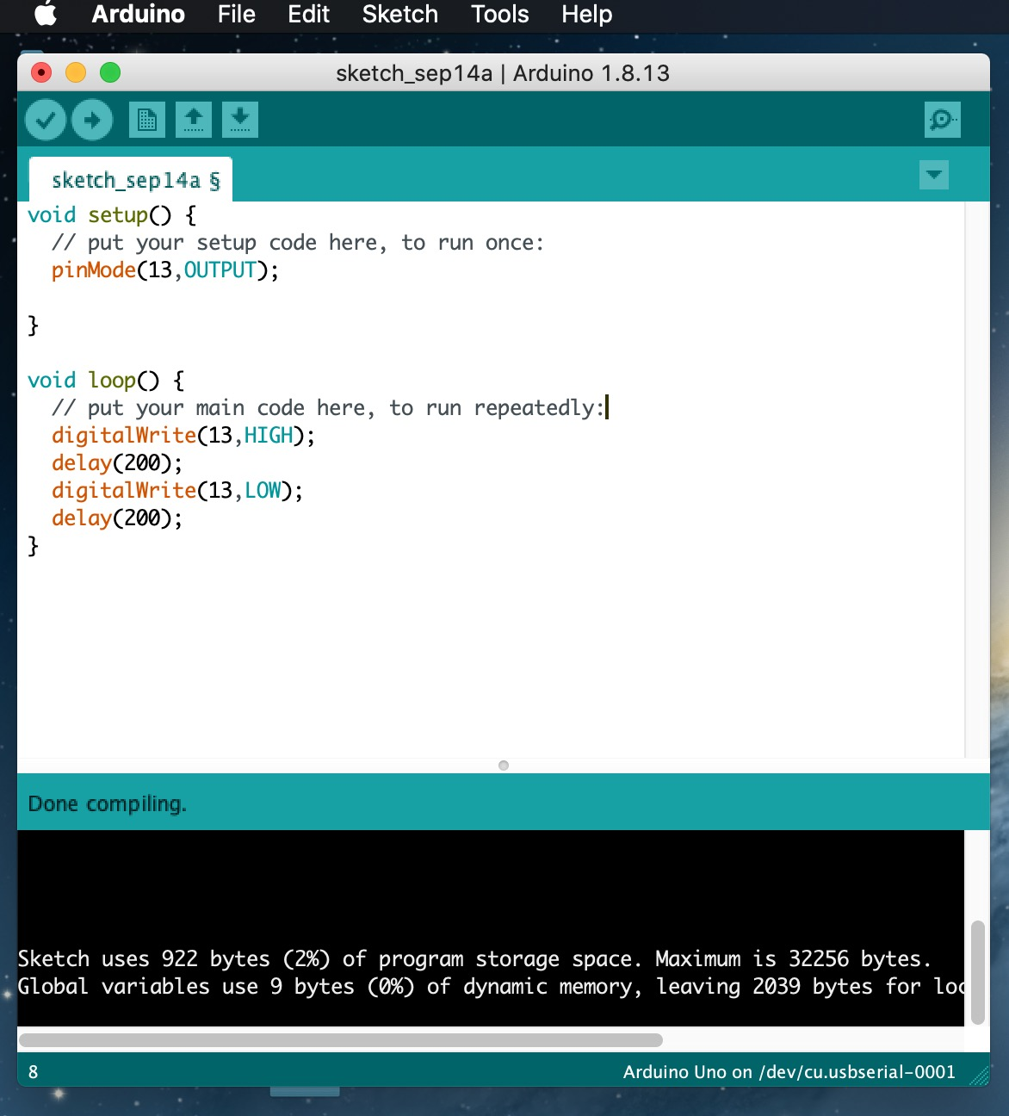

Click Tools to select Board Arduino Uno and /dev/cu.usbserial-0001

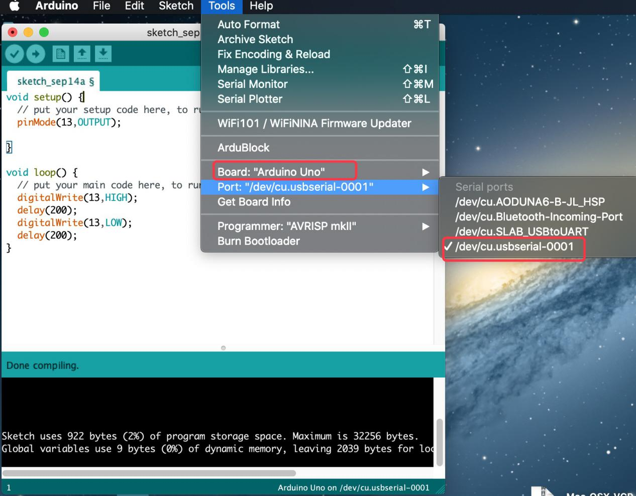

Tap **Upload** to upload code. If code is uploaded successfully, you will view **Done uploading**.

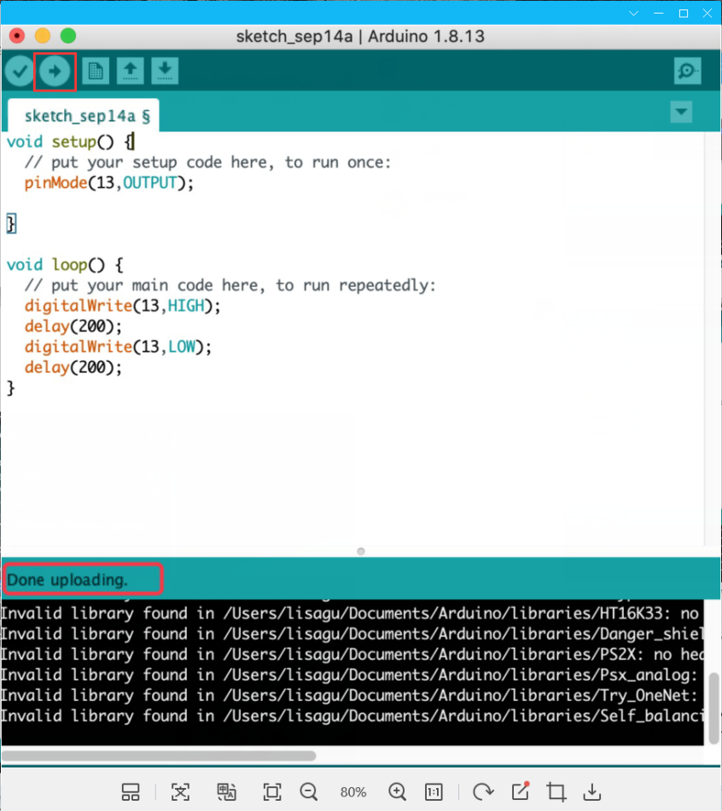

Note: If code is uploaded unsuccessfully, you need to install driver of CP2102, please continue to follow the instructions as below:

Download the driver of CP2102:

<https://www.silabs.com/products/development-tools/software/usb-to-uart-bridge-vcp-drivers>

1. Select Mac OSX edition

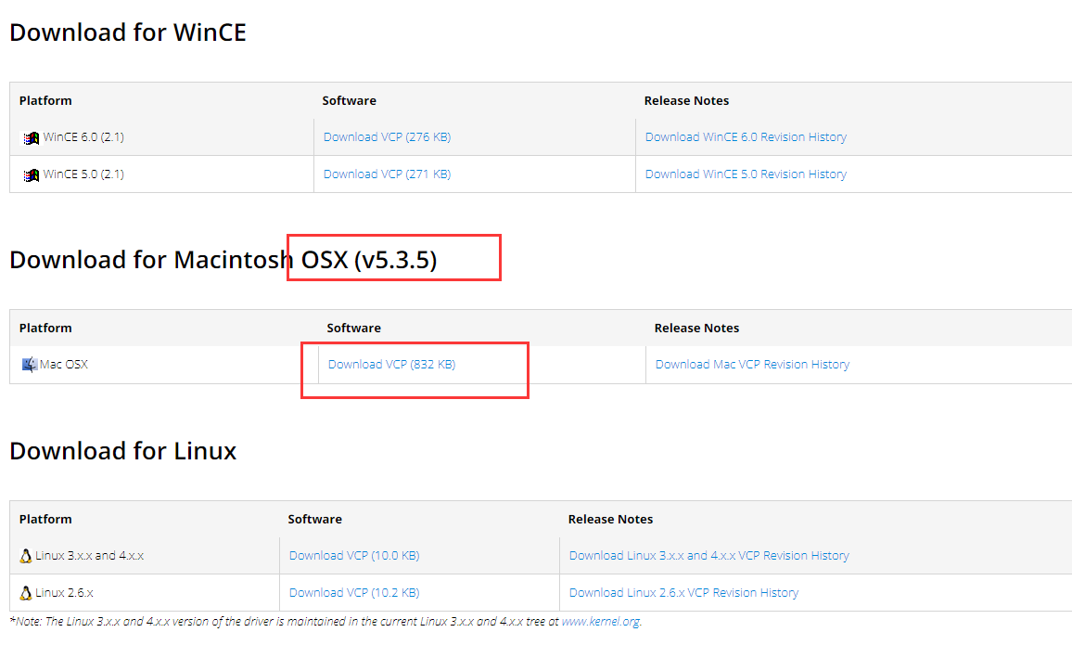

1. Unzip the downloaded package



1. Open folder and double-click **SiLabsUSBDriverDisk.dmg** file.

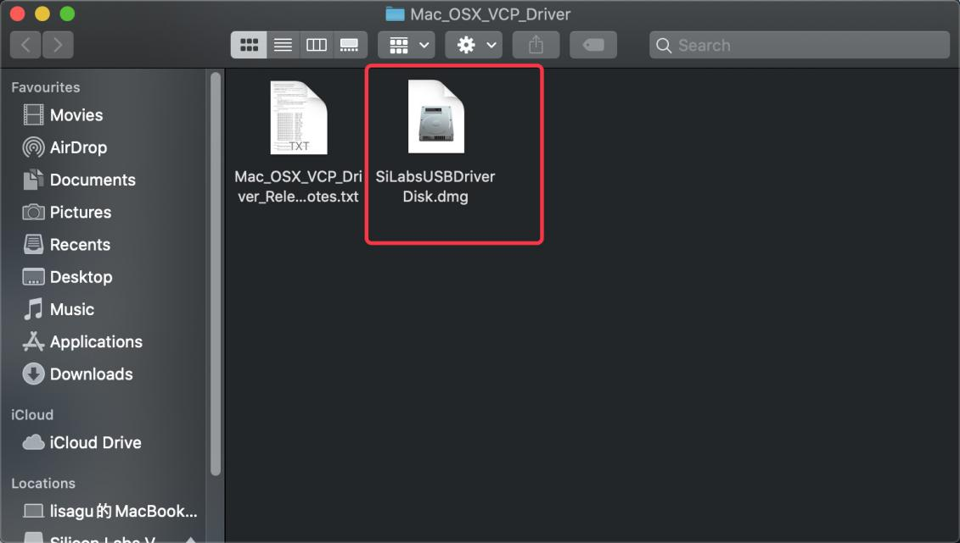

1. You will view the following files as follows:

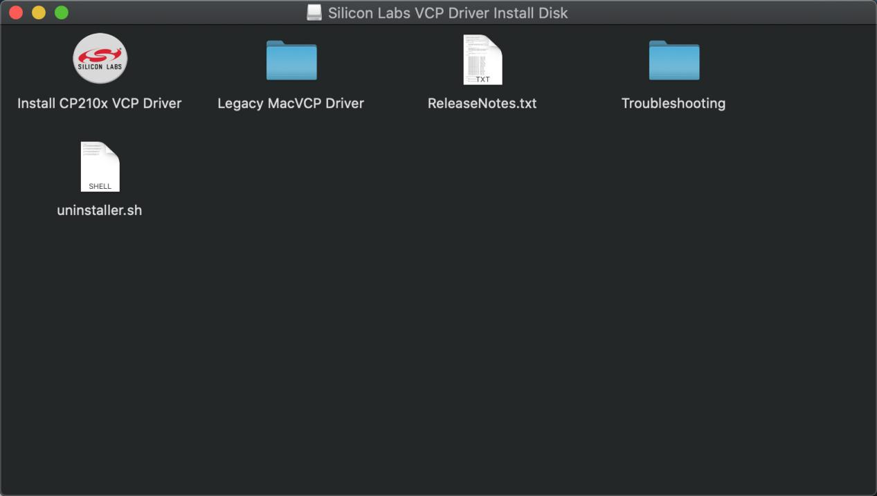

5. Double-click Install CP210x VCP Driver, tick **Don’t warn me....image** and tap **Open.**

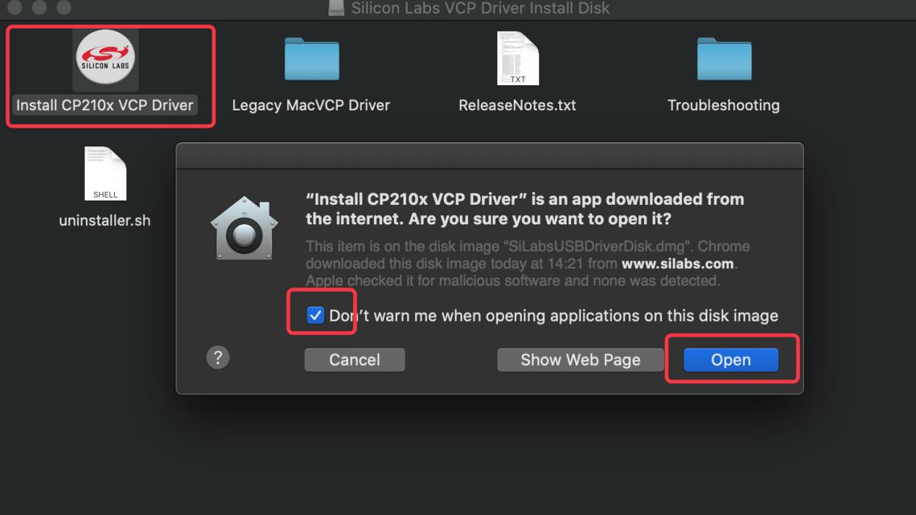

6. Tap **Continue**

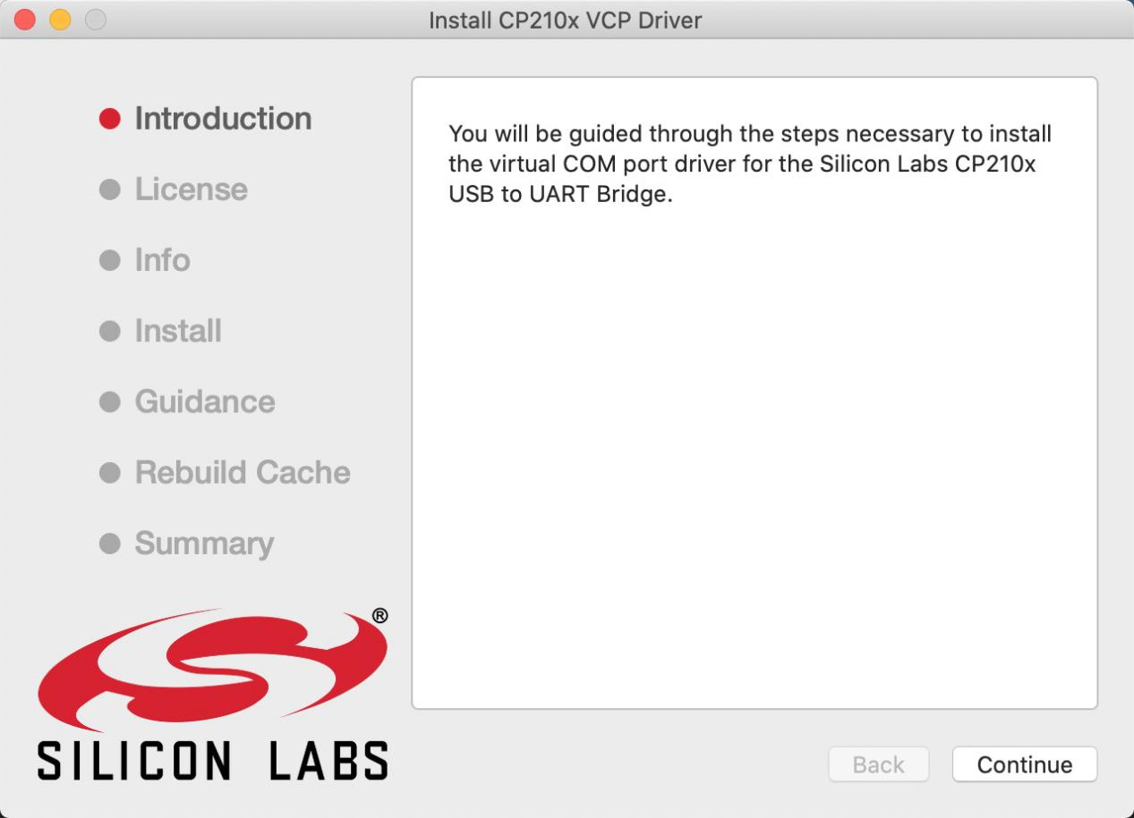

7. Tap **Agree,** and **Continue**

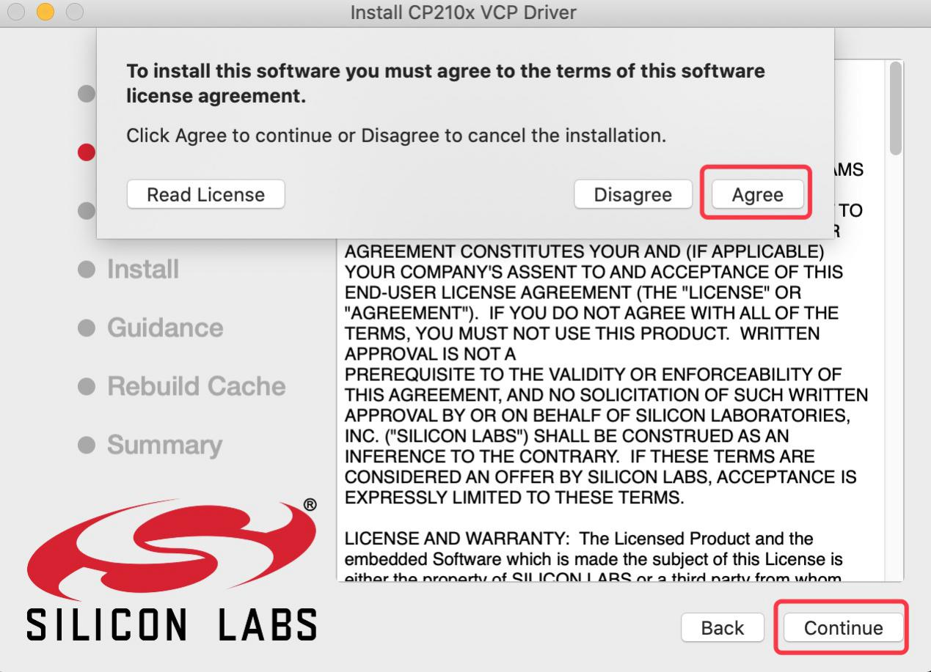

1. Click **Continue** and input your password.

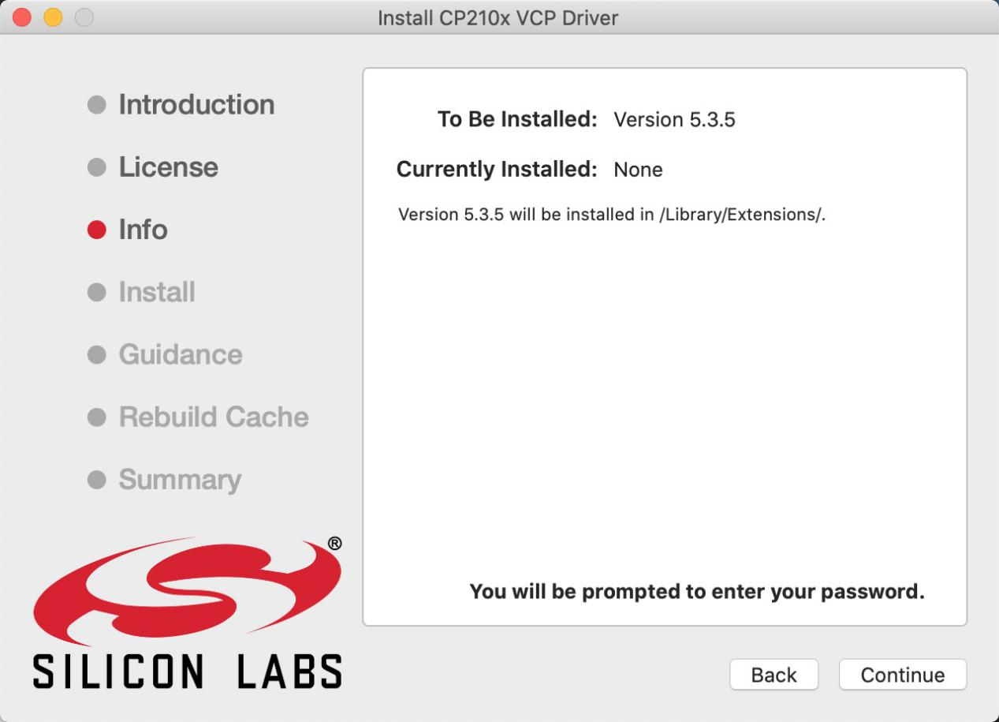

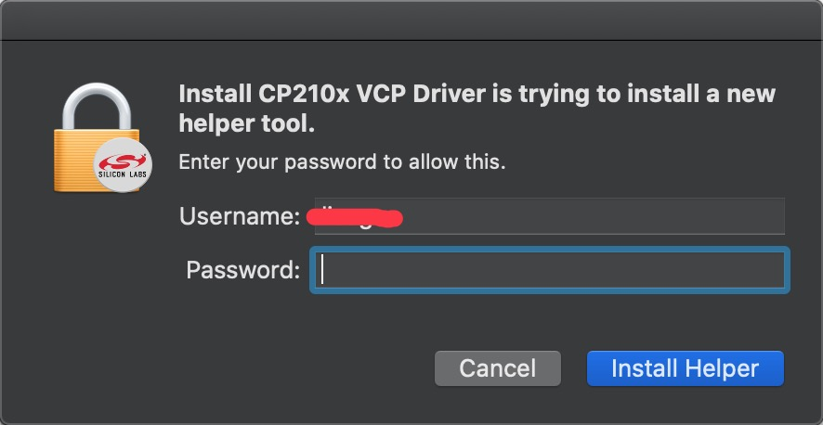

9. Click **Open Security Preferences**

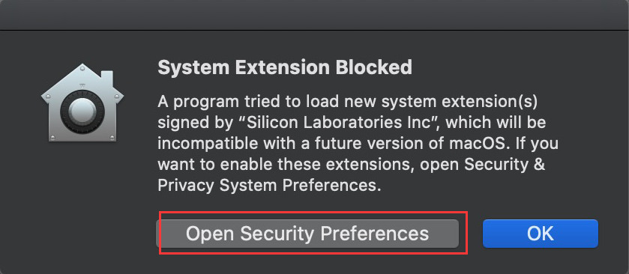

1. Click the lock to unlock security & privacy preference.

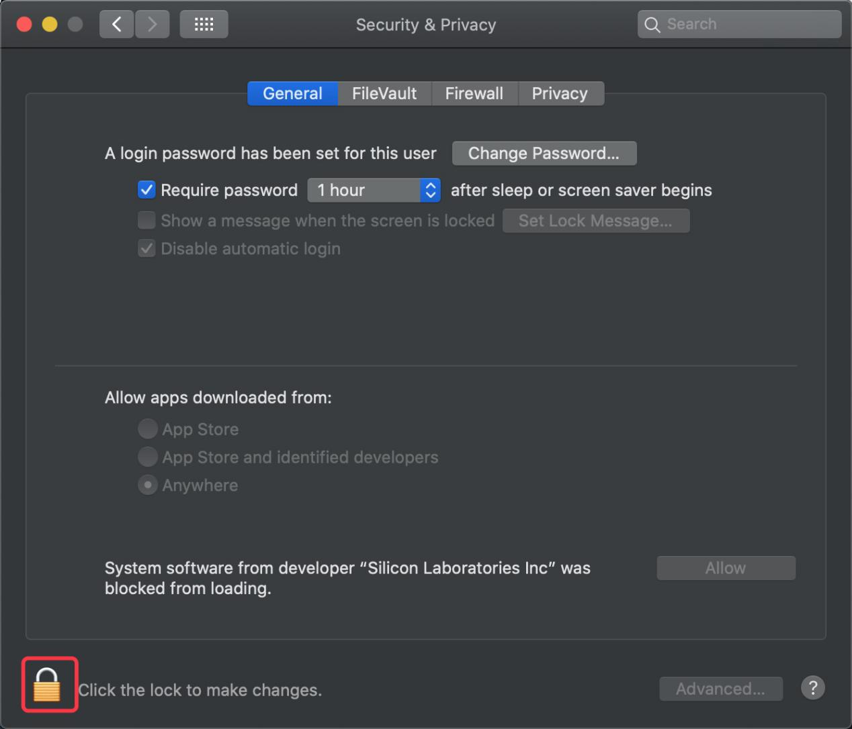

1. Tap **Unlock and** enter **your Username and password**

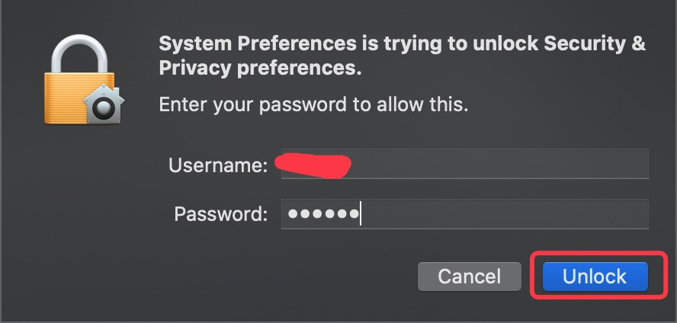

1. Then click **Allow**

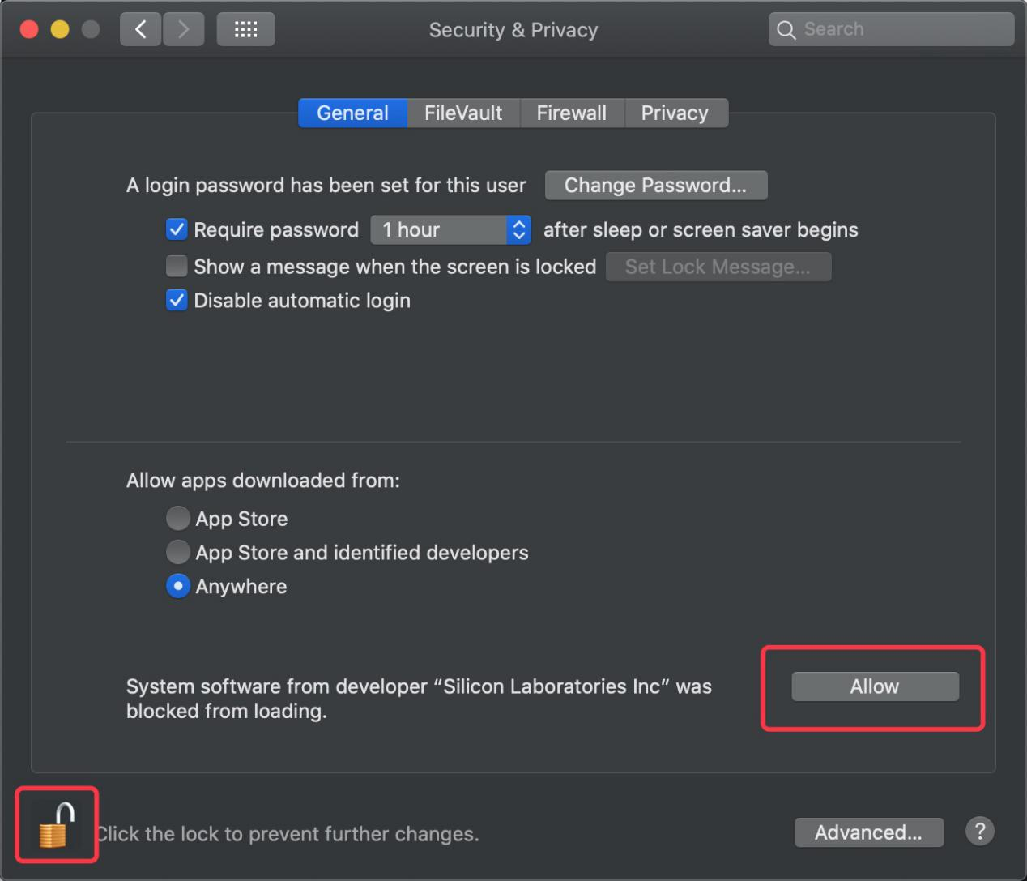

1. Back to installation page, and wait to install.

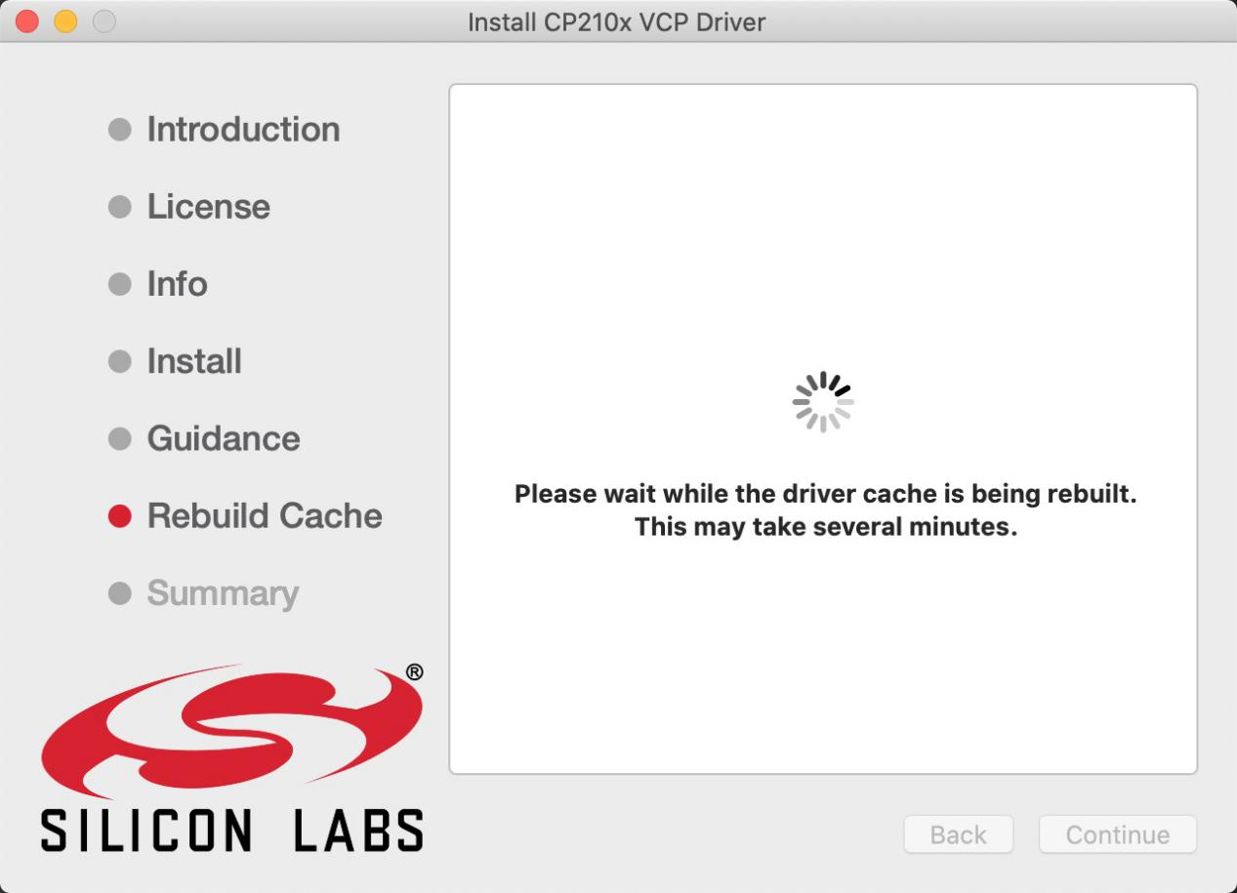

1. Successfully installed

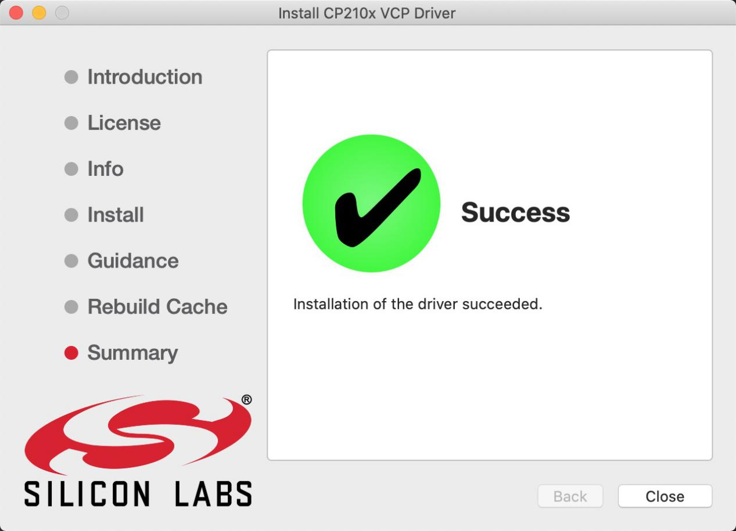

1. Then enter ArduinoIDE, click **Tools** and select Board **Arduino Uno** and **/dev/cu.SLAB_USBtoUAPT**

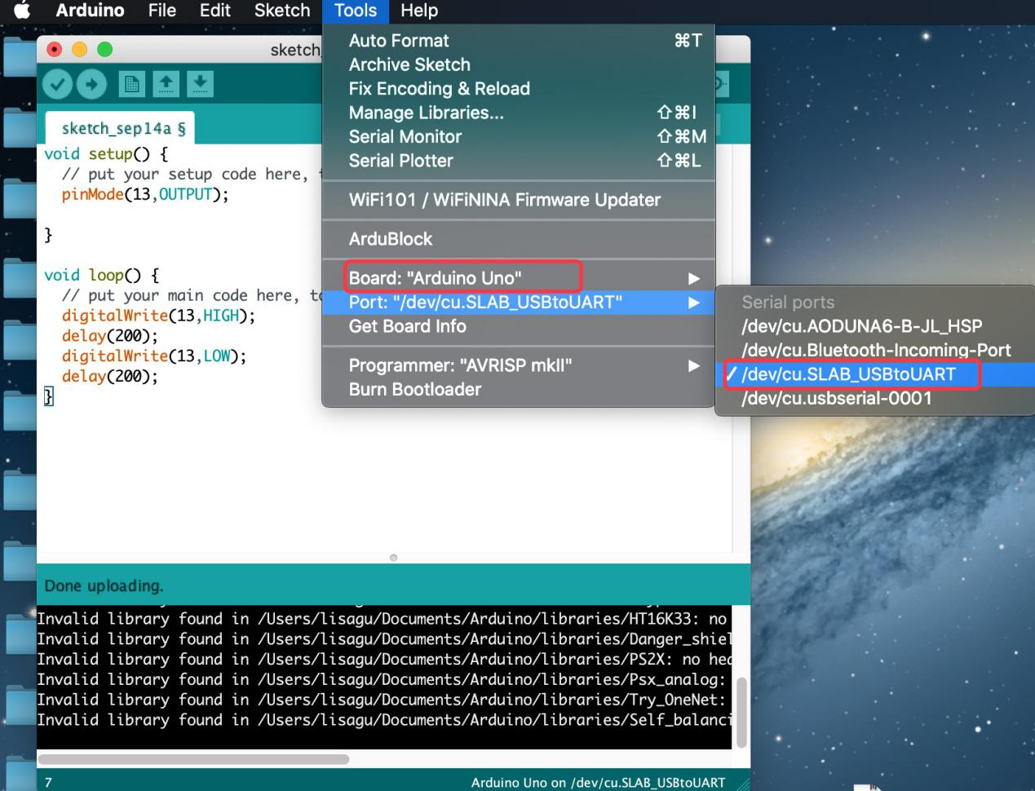

1. Click to upload code and show“Done uploading”.

